**SQL-Mongo Project – Spatial Data of US Wildfires**

BUAN 6320

Submitted by:

***Prem Kumar Pulluri***

|  |
| --- |
| **Activity** |
| Prepared Data Model and Created Physical DB |
| Loaded Data into Database |
| Wrote SQL Queries |
| Prepared Mongo Database |
| Loaded data into Mongo DB |
| Wrote Mongo Queries |
| Prepared Report |
| Reviewed Report |

Contents

Data Model 5

Assumptions/Notes About Data Entities and Relationships 5

Entity-Relationship Diagram 5

Physical Database 6

Assumptions/Notes About Data Set 6

Screen shot of Physical Database objects 6

Data in the Database 6

SQL Queries 7

Query 1 7

Question 7

Notes/Comments About SQL Query and Results (Include # of Rows in Result) 7

Translation 7

Screen Shot of SQL Query and Results 7

Query 2 8

Question 8

Notes/Comments About SQL Query and Results (Include # of Rows in Result) 8

Translation 8

Screen Shot of SQL Query and Results 8

Query 3 9

Question 9

Notes/Comments About SQL Query and Results (Include # of Rows in Result) 9

Translation 9

Screen Shot of SQL Query and Results 9

Query 4 10

Question 10

Notes/Comments About SQL Query and Results (Include # of Rows in Result) 10

Translation 10

Screen Shot of SQL Query and Results 10

Query 5 11

Question 11

Notes/Comments About SQL Query and Results (Include # of Rows in Result) 11

Translation 11

Screen Shot of SQL Query and Results 11

Query 6 12

Question 12

Notes/Comments About SQL Query and Results (Include # of Rows in Result) 12

Translation 12

Screen Shot of SQL Query and Results 12

Data Review for MongoDB 13

Assumptions/Notes About Data Collections, Attributes and Relationships between Collections 13

Physical Mongo Database 14

Assumptions/Notes About Data Set 14

Screen shot of Physical Database objects (Database, Collections and Attributes) 14

Data in the Database 14

MongoDB Queries/Code 15

Query 1 15

Question 15

Notes/Comments About MongoDB Query/Code and Results (Include # of Documents in Result) 15

Translation 15

Screen Shot of MongoDB Query/Code and Results 15

Query 2 16

Question 16

Notes/Comments About MongoDB Query/Code and Results (Include # of Documents in Result) 16

Translation 16

Screen Shot of MongoDB Query/Code and Results 16

Query 3 17

Question 17

Notes/Comments About MongoDB Query/Code and Results (Include # of Documents in Result) 17

Translation 17

Screen Shot of MongoDB Query/Code and Results 17

Query 4 18

Question 18

Notes/Comments About MongoDB Query/Code and Results (Include # of Documents in Result) 18

Translation 18

Screen Shot of MongoDB Query/Code and Results 18

Query 5 19

Question 19

Notes/Comments About MongoDB Query/Code and Results (Include # of Documents in Result) 19

Translation 19

Screen Shot of MongoDB Query/Code and Results 19

Query 6 20

Question 20

Notes/Comments About MongoDB Query/Code and Results (Include # of Documents in Result) 20

Translation 20

Screen Shot of MongoDB Query/Code and Results 20

# Data Model

## Assumptions/Notes About Data Entities and Relationships

Include assumptions about data entities and their relationships with each other.

1. The relationship between the primary key in the above-mentioned tables with the **fire_table** main table is **one to many relationships** other than Source_System_info as the FPA_ID, which is primary key has single record mapping with the foreign key, all other tables have multiple values repeated in foreign key column.
2. The **nwcg_agency_identifier_table** has the primary key unitID which has a **one to many relationships** to the **Fire_data_Table**.
3. nwcg_location_info has one to many relationship with **nwcg_agency_identifier_table** with State and Gacc Columns as primary composite key.
4. stat_cause_table has one to many relationship with fire_table with stat_cause_code as primary key.
5. location_info has one to many relationship with fire_table with Latitude and Longitude as primary composite key.
6. fips_info has one to many relationship with location_info with FIPS_CODE and FIPS_NAME as composite primary key.
7. mtbs_info has one to many relationship with fire_table with MTBS_ID as primary key.
8. Source_reporting_info has one to many relationship with fire_table with Source_Reporting_Unit as the primary key.
9. Owner_info has one to many relationship with fire_table with Owner_ID as the primary key.
10. Ics_209_info has one to many relationships with fire_table with ICS_209_Incident_number as the primary key with Non Identifying relationship.
11. Each owner may own land on many locations, while every single location can have only one land owner.
12. Many fire incidents may occur due to one statistical cause, each fire incident is caused by only one statistical cause.
13. Each MTBS identifier may identify many fire incidents, each fire is identified by only one MTBS identifier.
14. Each ICS-209 report identifier may identify many fire incidents, each fire is identified by only one MTBS identifier.
15. Each FIPS may represent many locations, each location is represented by one FIPS.
16. On one location many times a fire may occur, one fire would occur only on one location
17. Each location may have many NWCG Units, Each NWCG unit would be on only one location.
18. For each Active NWCG unit many fire incidents may occur, for each fire there was one unique NWCG unit active.
19. Each source reporting unit may prepare many fire reports, each fire report is prepared by only one source reporting unit.

Include reasons why the data model is in 3NF.

* Each table has its own functionality and serves its own purpose.
* Every table has a primary key and each table contains only atomic values instead of group values which satisfies the condition of 1NF.
* Every column in each table is dependent on a single primary key and not on a composite key which satisfies the condition of 2NF.
* There are no transitive functional dependencies between any column in table which satisfies the condition of 3NF

## Entity-Relationship Diagram

## ER DIAGRAM

## 

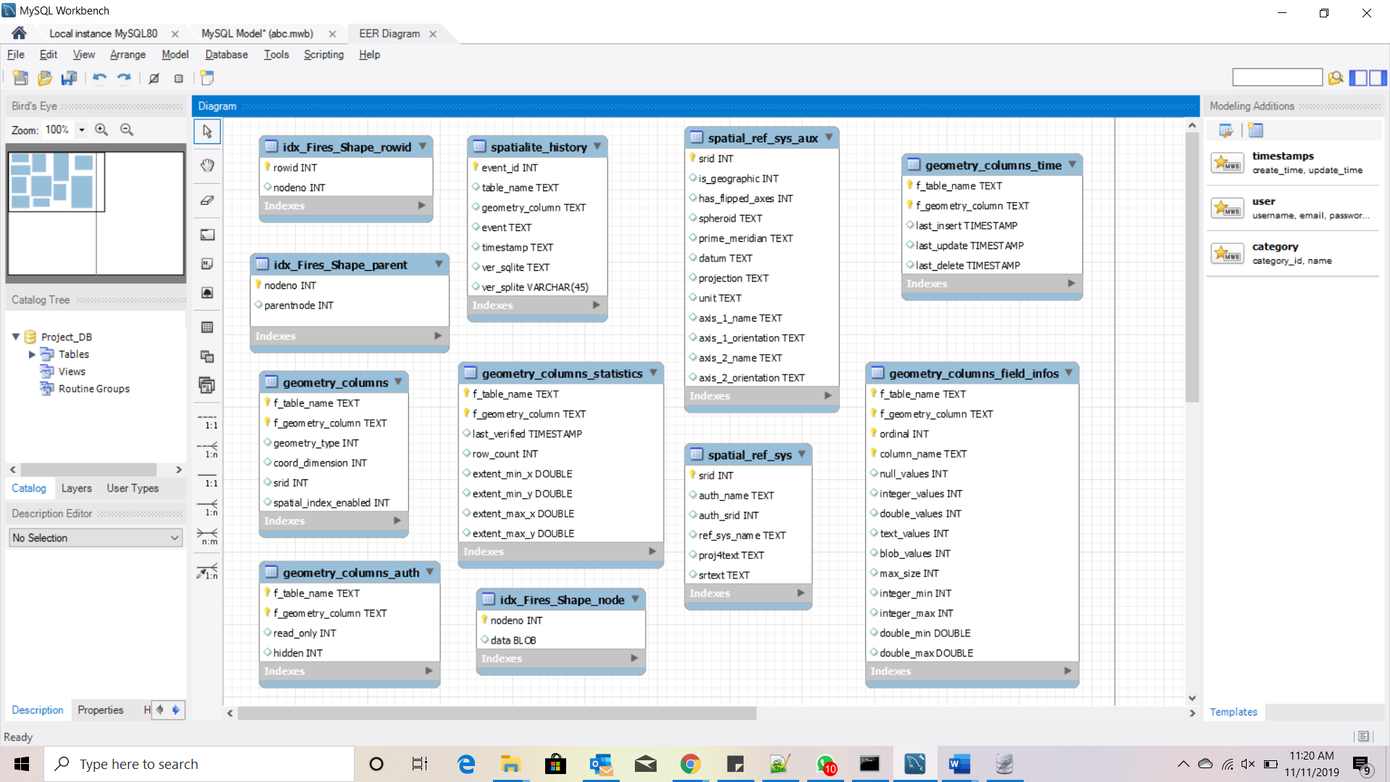

# Physical Database

## Assumptions/Notes About Data Set

Include any assumptions made about data such as empty fields, sparse data, bad data, etc.

**Bad Data**:

1. The column county in the original fire table does not have a **normalized entry** for example the county name harding is entered as Harding or Harding-county or 39 in different rows because of which we are unable to take the combination of state and county as unique values
2. The combination of columns fips_code,state should be unique value but due to no normalized entry of fips_name we are unable to use the combination as a primary key.

## Screen shot of Physical Database objects

* owner_info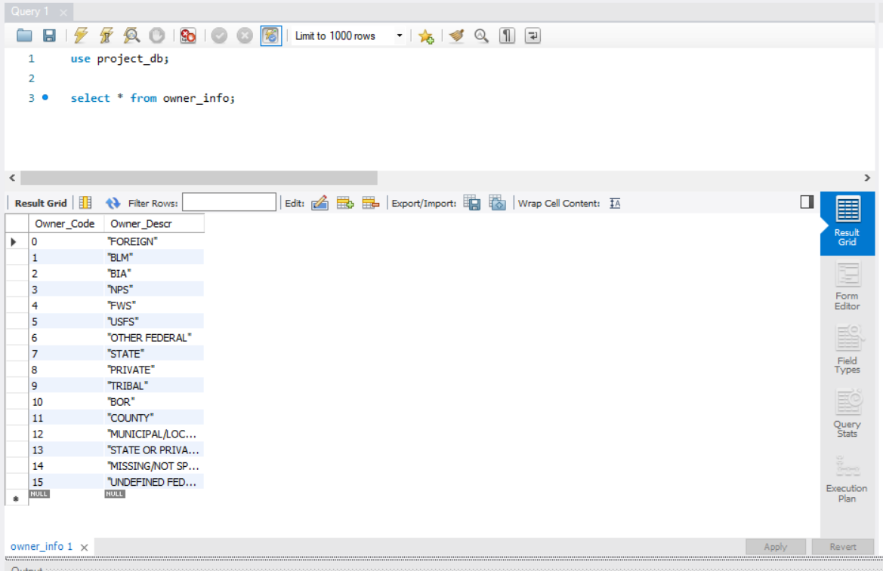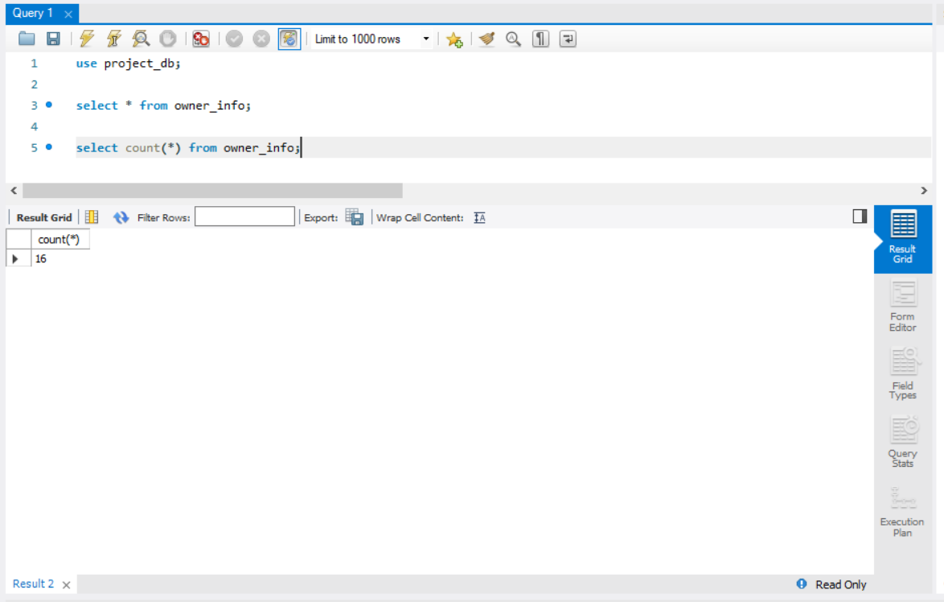
* stat_cause_info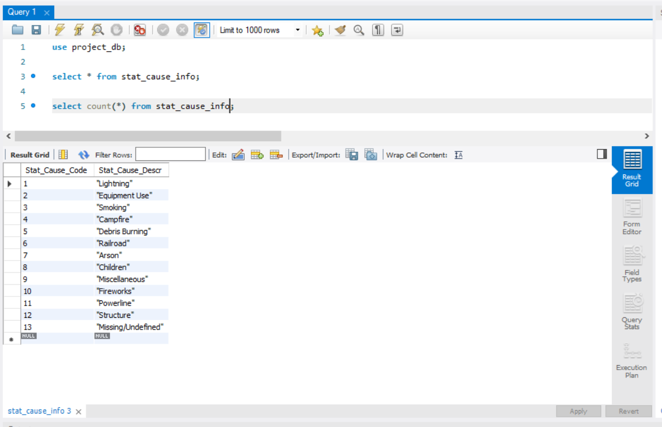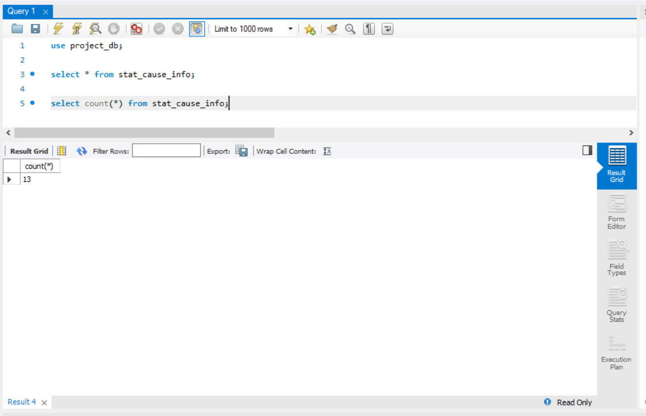
* mtbs_info

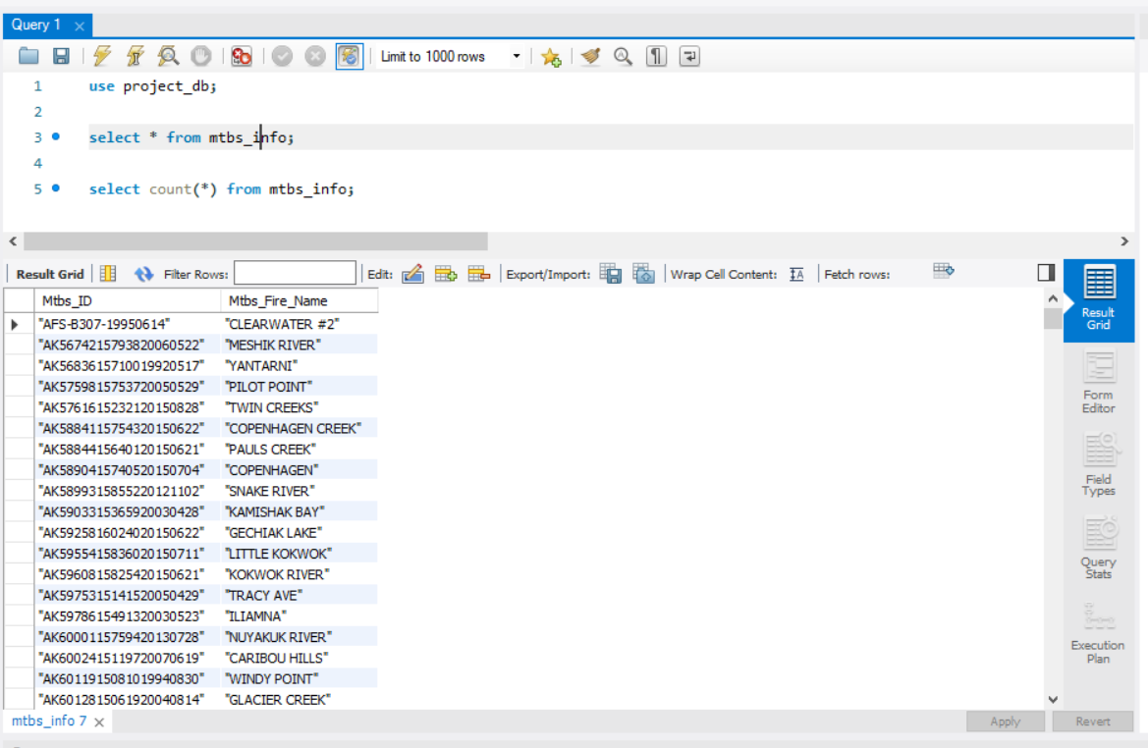

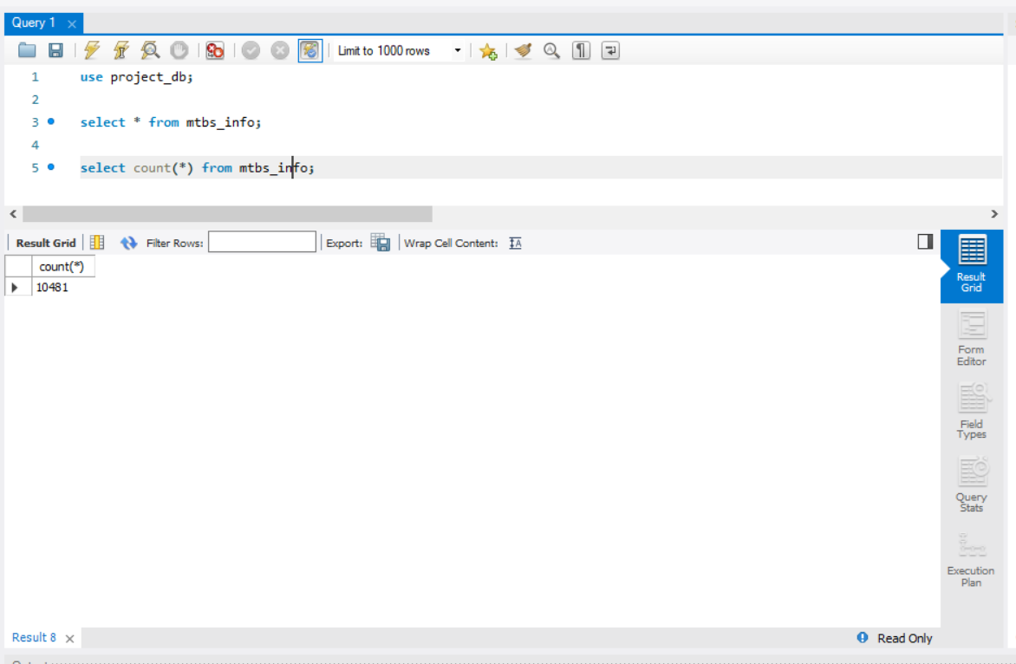

* ics_209_info

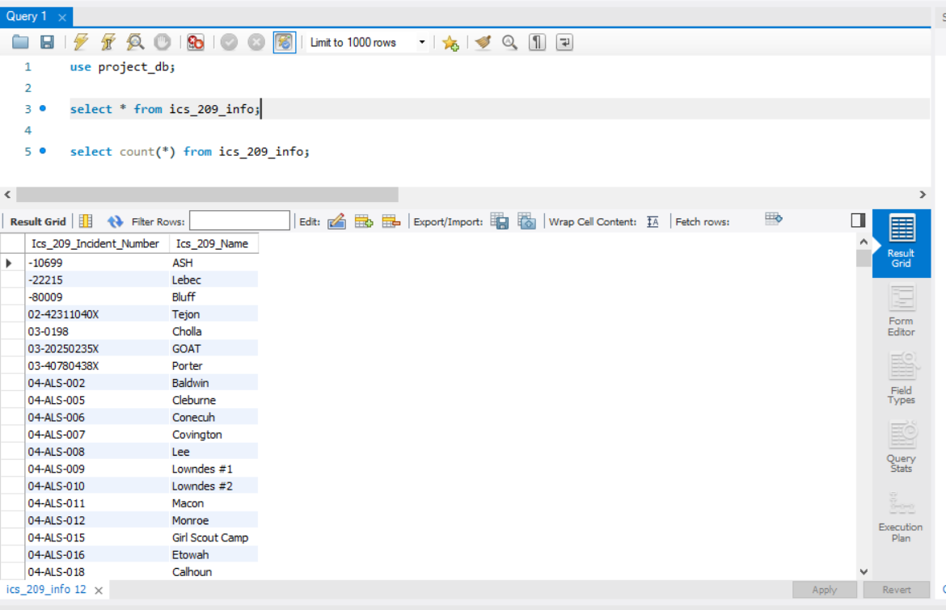

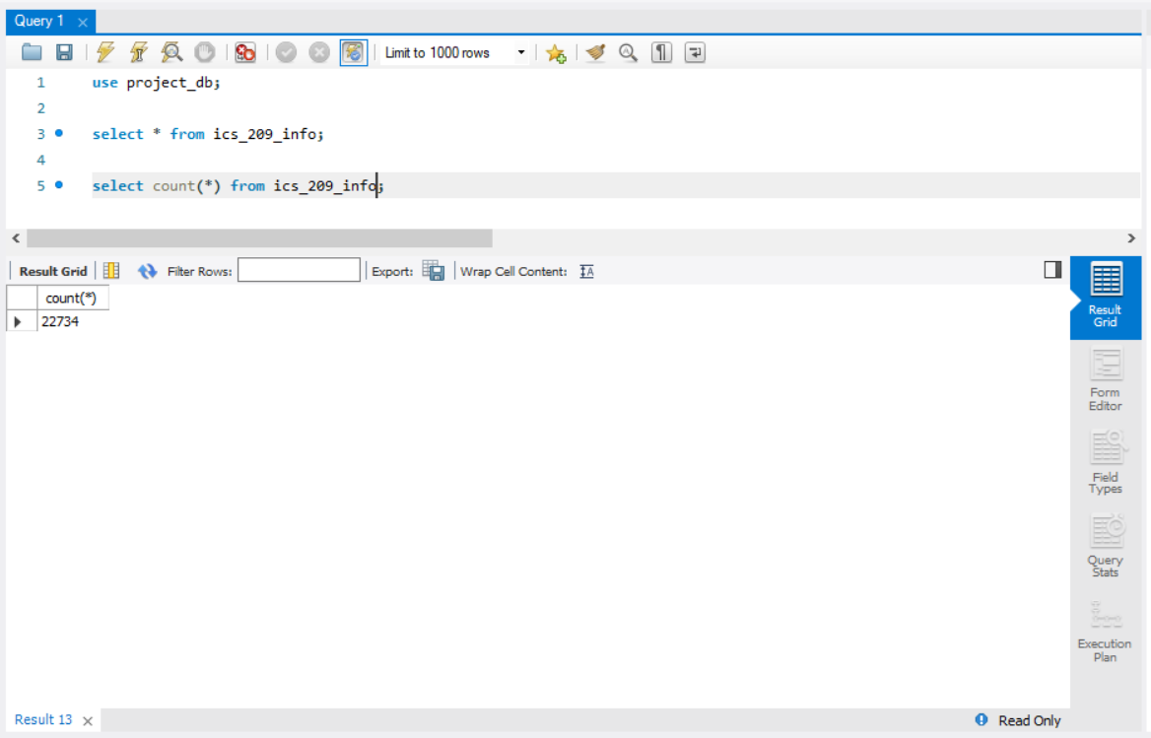

* source_system_info

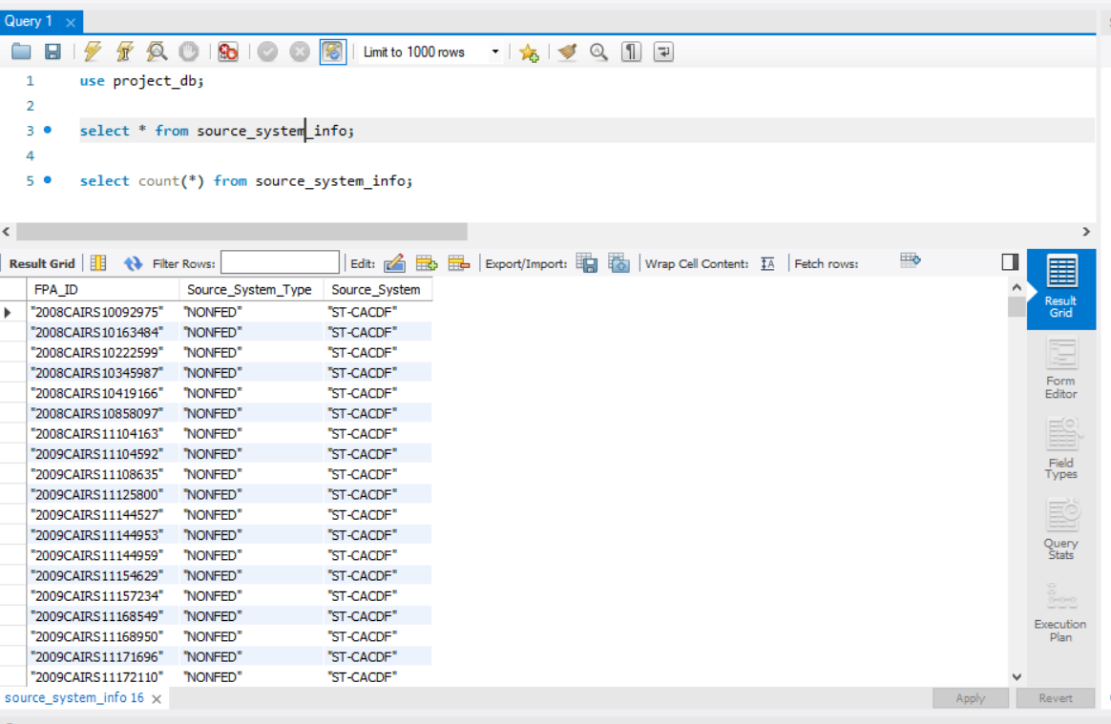 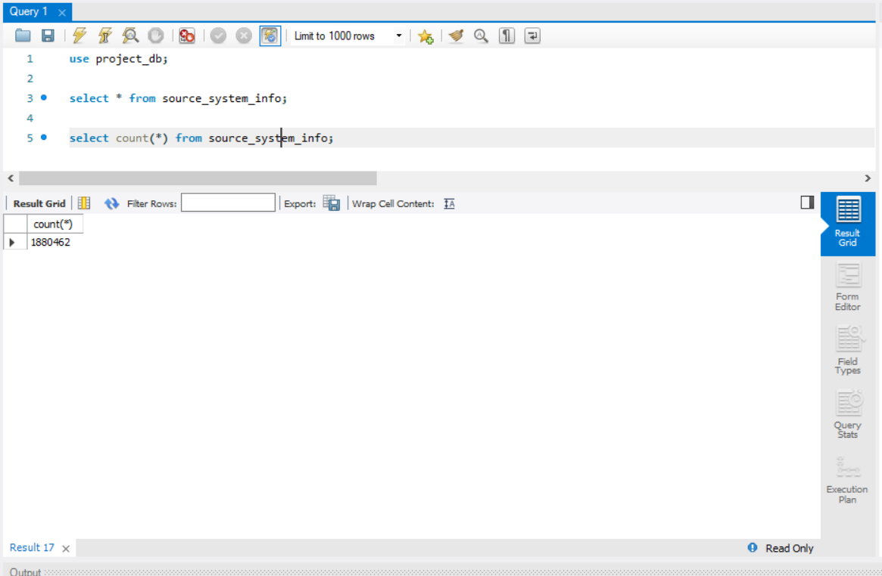

* source_reporting_info

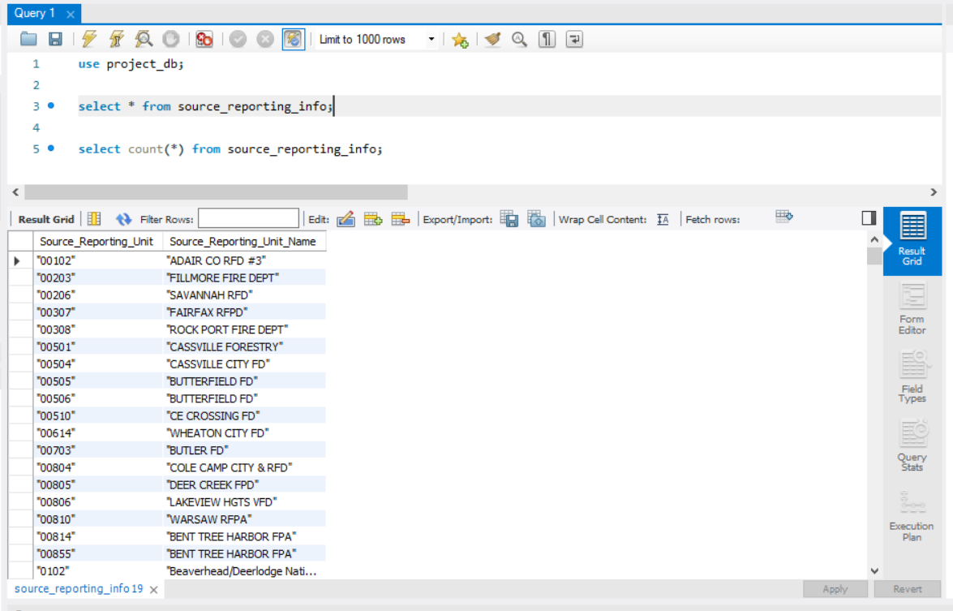 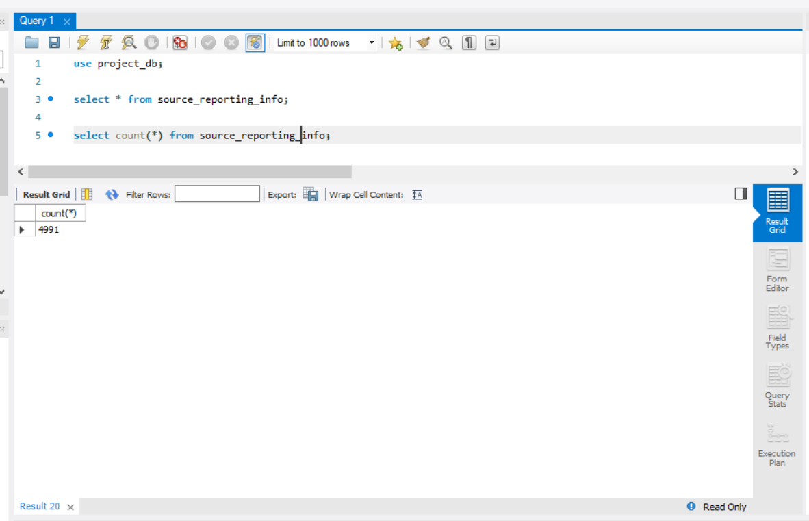

* fips_info

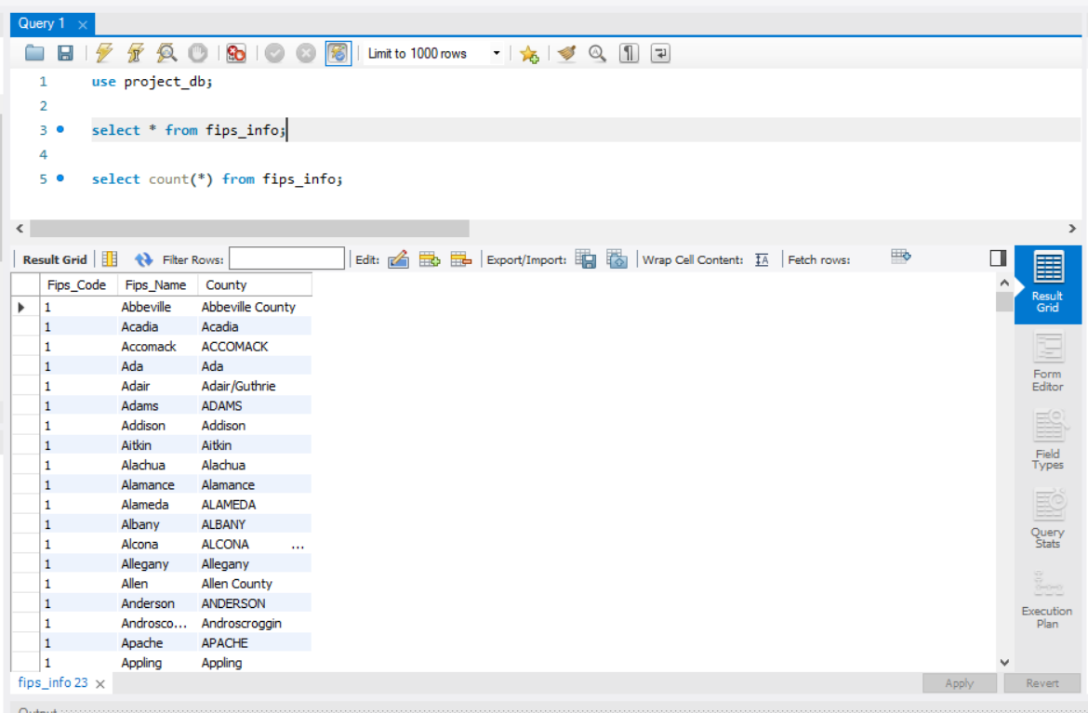 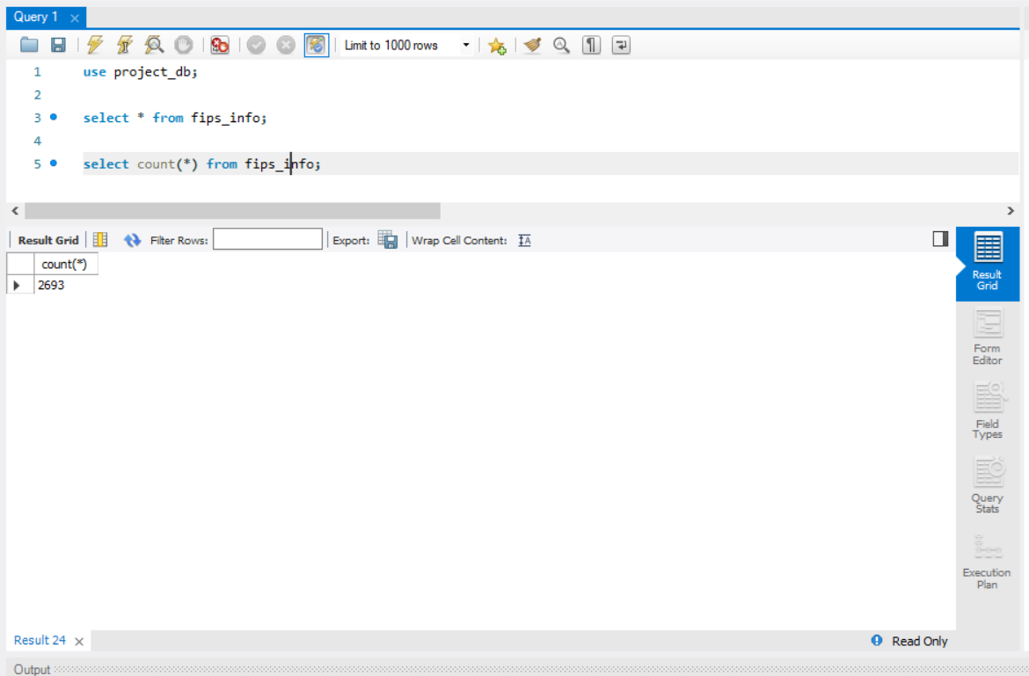

* location_info

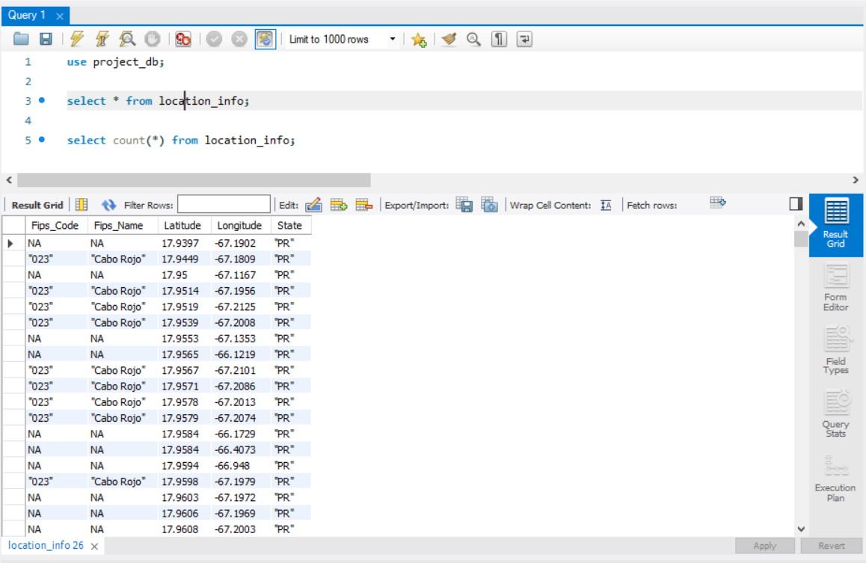 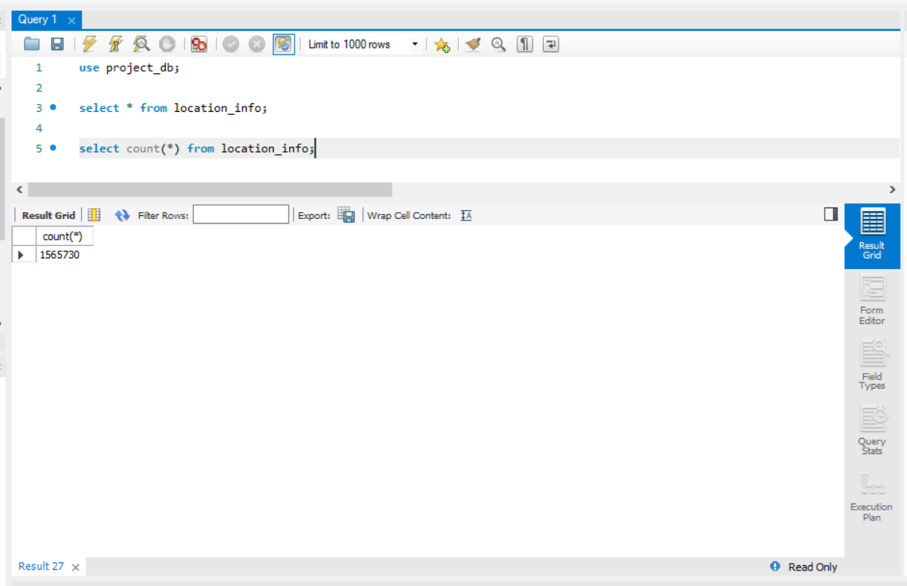

* nwcg_location_info

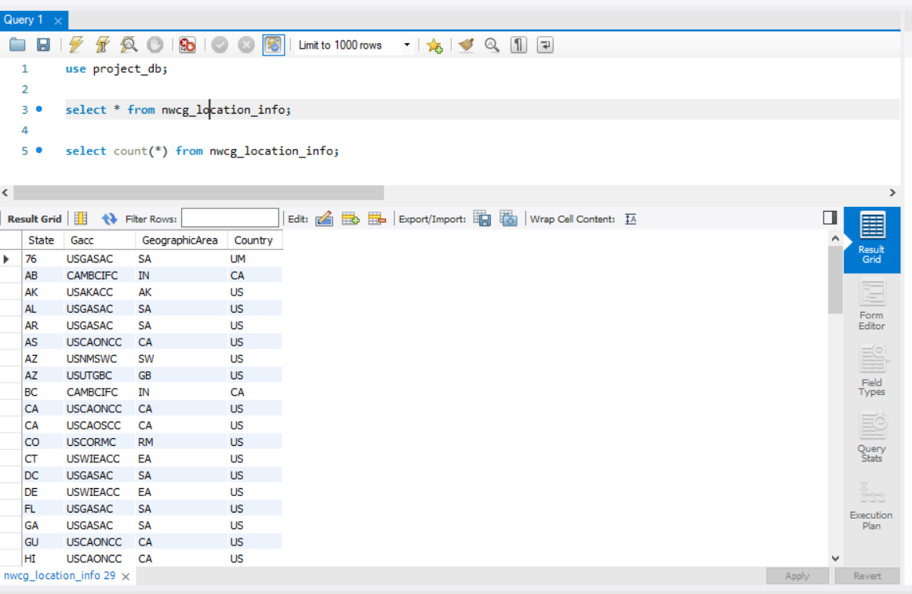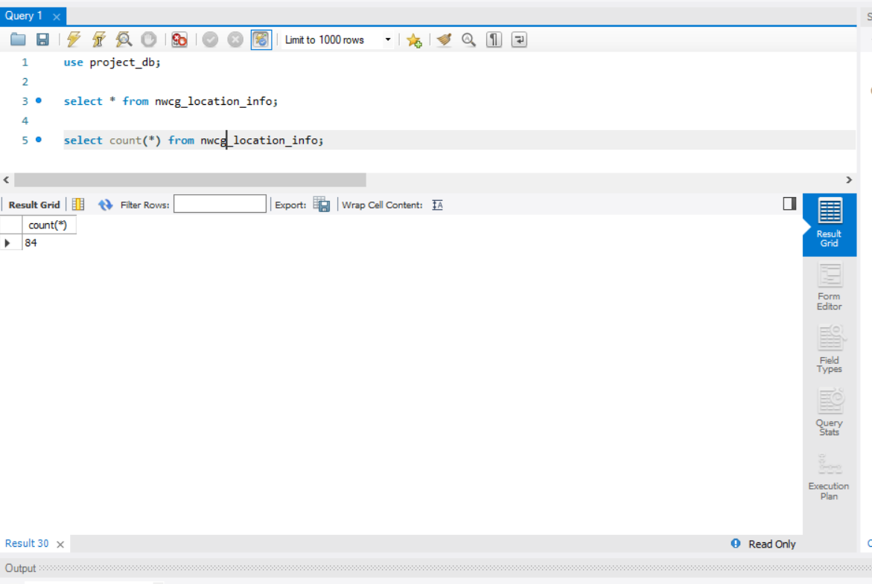

* nwcg_agency_identifier_table

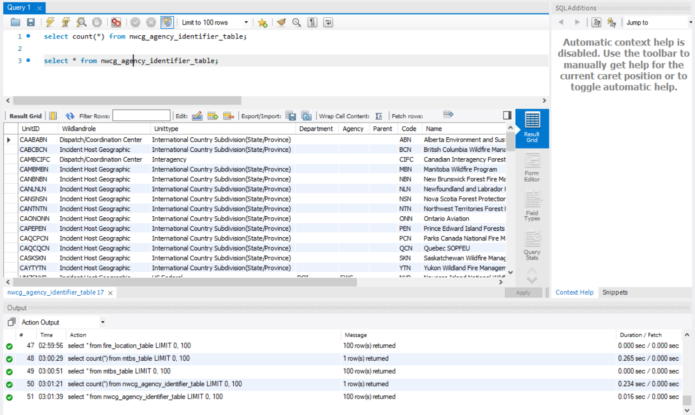

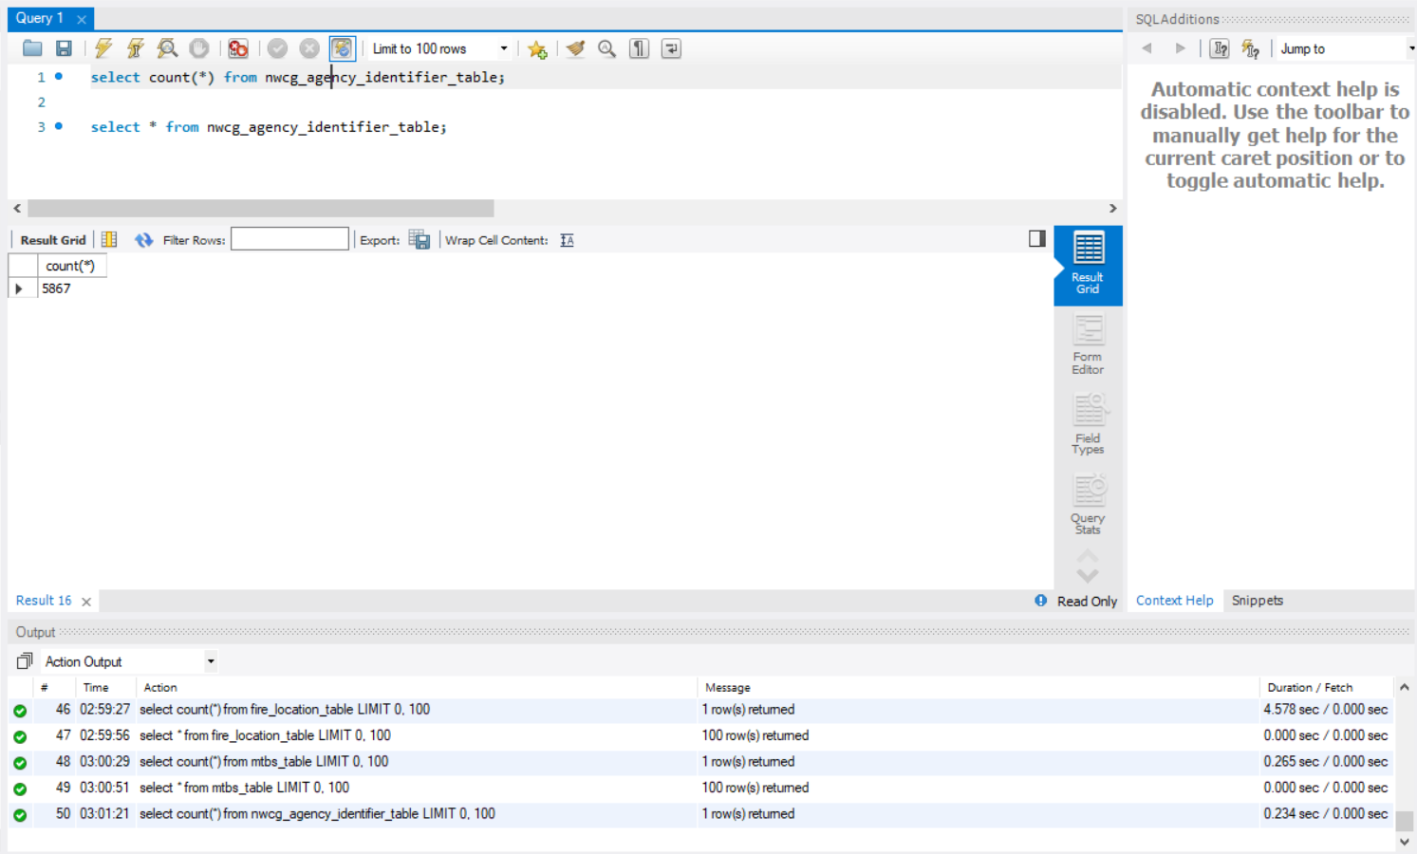

* fire_table 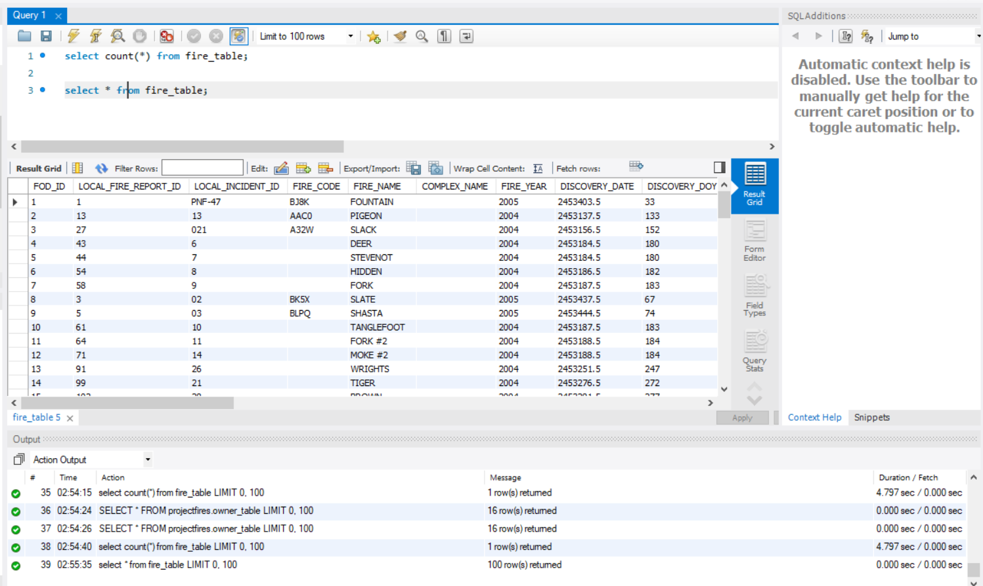 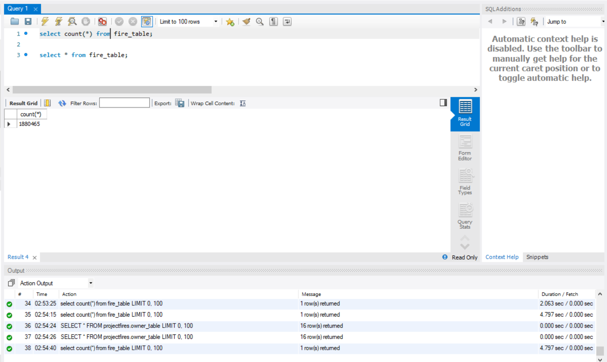

## Data in the Database

|  |  |  |  |
| --- | --- | --- | --- |
| **Table Name** | **Primary Key** | **Foreign Key** | **# of Rows in Table** |
| stat_cause_info | Stat_Cause_Code |  | 13 |
| owner_info | Owner_Code |  | 16 |
| ics_209_info | Ics_209_Incident_Index |  | 22734 |
| mtbs_info | Mtbs_ID |  | 10481 |
| source_reporting_info | Source_Reporting_Unit |  | 4991 |
| source_system_info | FPA_ID |  | 1880462 |
| location_info | Latitude, Longitude | fips_info_Fips_Code  fips_info_Fips_Name | 1565730 |
| fips_info | Fips_Code, Fips_Name |  | 2693 |
| nwcg_location_info | State,Gacc |  | 84 |
| nwcg_agency_identifier_table | UnitID, Agency | nwcg_location_info_State  nwcg_location_info_Gacc | 5867 |
| fires_table | FOD_ID, Fire_Size | ics_209_info_Ics_209_Incident_Number  source_system_info_FPA_ID  nwcg_agency_identifier_table_UnitID  nwcg_agency_identifier_table_Agency  source_reporting_info_Source_Reporting_Unit  owner_info_Owner_Code  mtbs_info_Mtbs_ID  stat_cause_info_Stat_Cause_Code  location_info_Latitude  location_info_Longitude | 1880465 |

## SQL Queries

## Query 1

### A leading beverage company has announced a billion-dollar fund for removing debris from forests, rivers and mountains in the US. All states are interested. Which state has the best chance to win a share of the fund?

### As all the states are interested in the billion-dollar fund we group by state, but the state with which has highest number of fires will receive the fund. AK has the highest fires.

### Translation : Select states from location by joining it with fires on latitude and longitude and group by state in descending order.

### Screen Shot of SQL Query and Results:

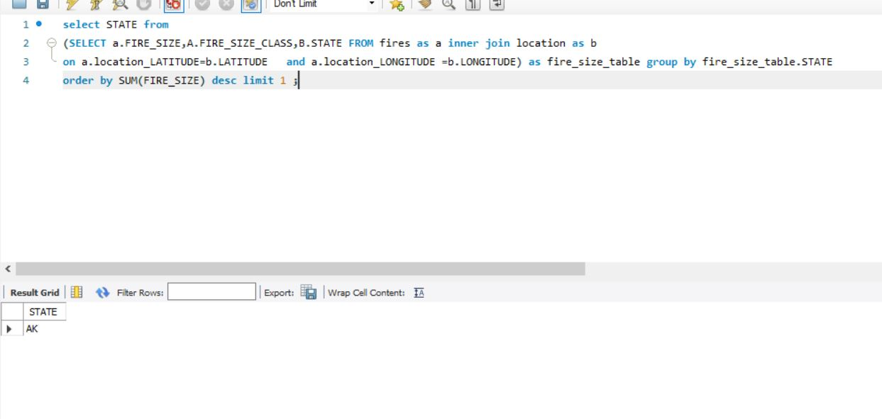

## Query 2

### One of the reporting agencies has suggested that children be banned from its forests unless there is one adult for every 3 children in a group visiting a forest. Name 3 forests where this would be the most appropriate.

### As the reporting agencies has suggested every 3 children should be accompanied by one adult, we group by source reporting unit in descending order and selecting first three forests will give us 3 rows.

### Translation: select source _reporting_unit_name from source_reporting table by joining on source reporting unit where stat_cause_code is 8 and source_reporting_unit name is like forest and grouping them by source _reporting_unit_name in descending order.

### Screen Shot of SQL Query and Results:

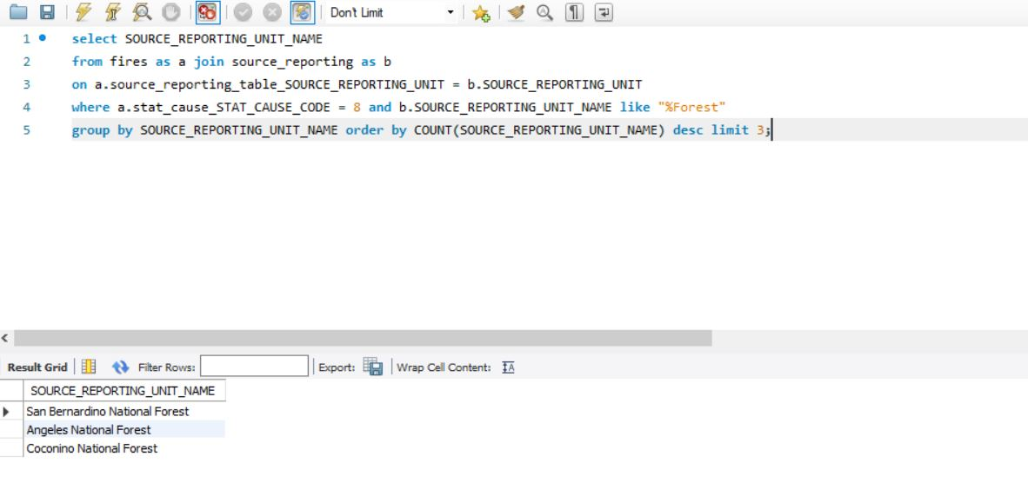

## Query 3

### One advocacy group says human actions and not Nature is to blame for most wildfires. Write a query that supports this statement.

### As the statement states human actions are to be blamed for most wildfires, we need the count the number of fires that are caused by human and nature. If the count of fires caused by human are more this proves the above statement is true. 2 rows are retrieved.

### Translation: select cause and count of fires from fires table where the stat_cause_descr is lightning, nature and human and group by cause.

### Screen Shot of SQL Query and Results:

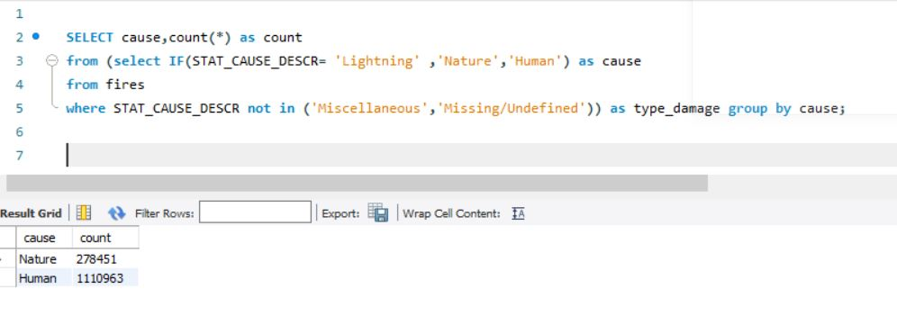

## Query 4

### How many wildfires were reported by more than one unit/agency?

### Retrieve the number of wildfires reported in more than one unit/agency. One row is retrieved.

### Translation : select count of source_reporting_name from fires and source_reporting table by them on source _reporting_unit group by fire_name and having no of units greater than 1.

### Screen Shot of SQL Query and Results:

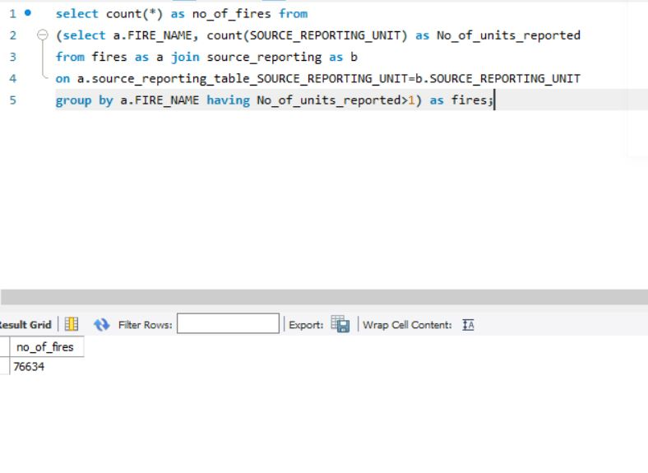

## Query 5

### What were the forests that had more than one fire that lasted more than two days?

### Retrieve the forests where the fires lasted for more than 2 days. 128 rows were retrieved.

### Translation: select source reporting unit name from source_reporting table by joining it with fires on source reporting unit where the difference between controlled date and discovery date is greater than 2 and source reporting unit name like forest and grouping by source reporting unit having count of source reporting unit name is greater than 1.

### Screen Shot of SQL Query and Results:

## Query 6

### Which forest had the most number of fires?

### Report the forest which has most number of fires. One row is retrieved

### Translation: select source_reporting_unit_name from source_reporting_unit table by joining it with fires table on soure_reporting_unit where source_reporting_unit_name like forest and grouping it by source_reporting_unit_name in descending order.

### Screen Shot of SQL Query and Results:

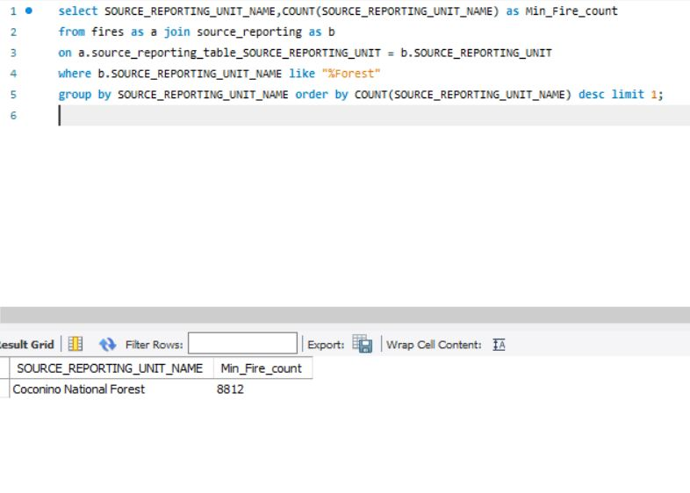

# Data Review for MongoDB

## Assumptions/Notes About Data Collections, Attributes and Relationships between Collections

The wildfires database in MongoDB contains 2 collections:

1)Fires

2) NWCG

Relationship: NWCG_REPORTING_UNIT_ID  field in Fires collection is linked with UnitId field in NWCG Collection

# Physical Mongo Database

## Assumptions/Notes About Data Set

## Screen shot of Physical Database objects (Database, Collections and Attributes)

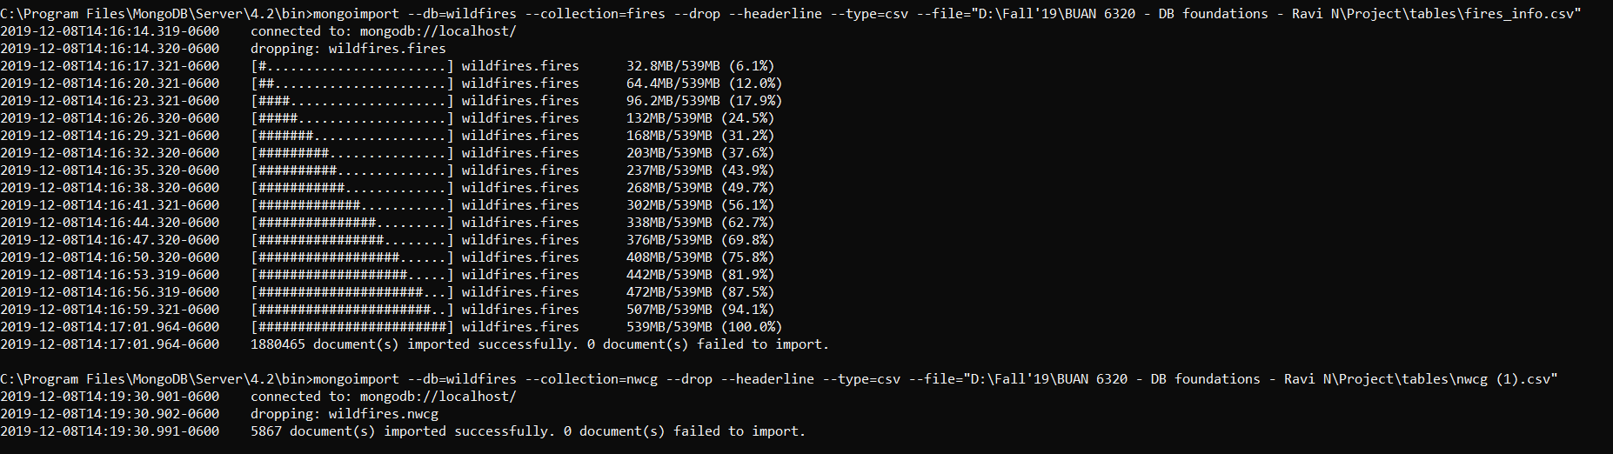

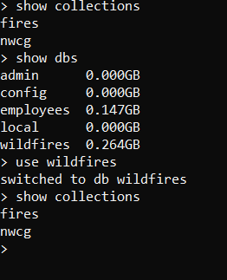

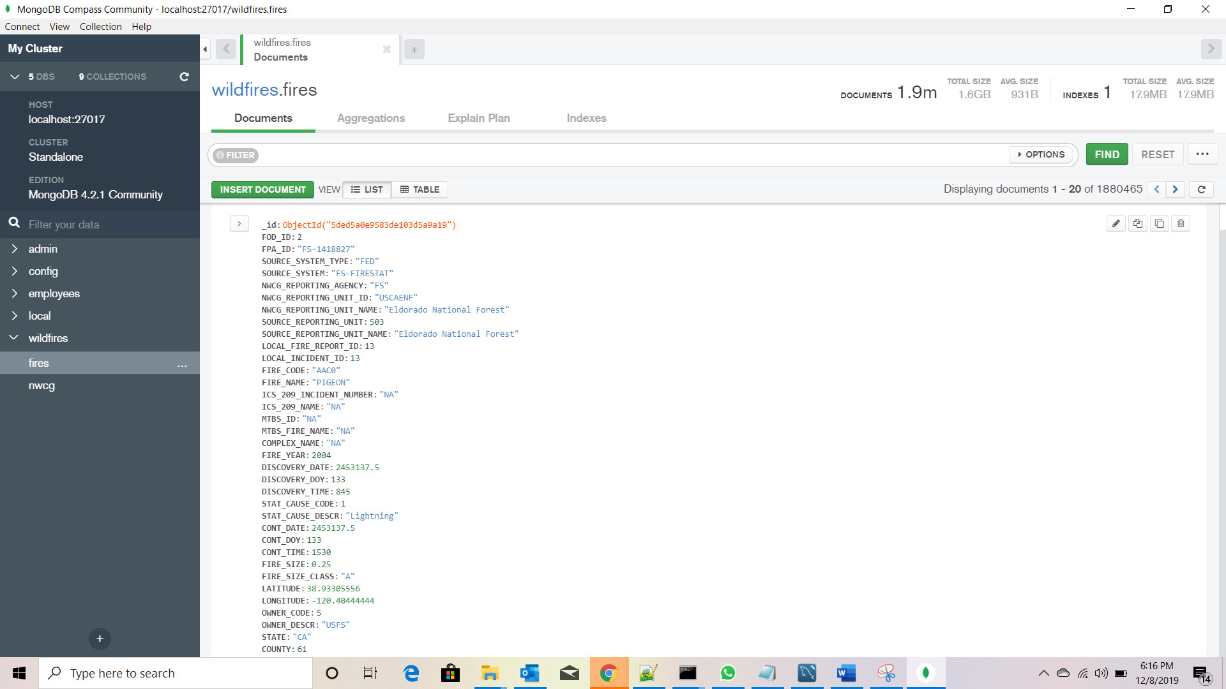

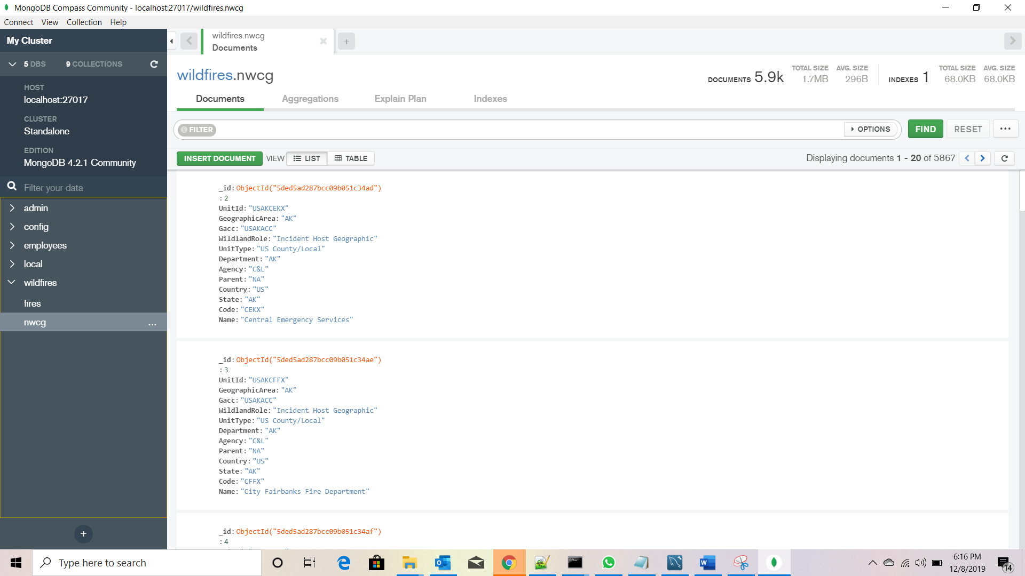

## Data in the Database

|  |  |  |
| --- | --- | --- |
| **Collection Name** | **Relationshps With Other Collections (if any)** | **# of Documents in Collection** |
| Fires | NWCG_REPORTING_UNIT_ID  field in Fires is linked with UnitId field in NWCG Collection | 1880465 |
| NWCG | NWCG_REPORTING_UNIT_ID  field in Fires is linked with UnitId field in NWCG Collection | 5867 |

# MongoDB Queries/Code

## Query 1

### A leading beverage company has announced a billion-dollar fund for removing debris from forests, rivers and mountains in the US. All states are interested. Which state has the best chance to win a share of the fund?

### As all the states are interested in the billion-dollar fund we group by state, but the state with which has highest number of fires will receive the fund. AK has the highest fires.

### Translation: Project the highest fire_damage grouping by state in descending order.

### Screen Shot of MongoDB Query/Code and Results:

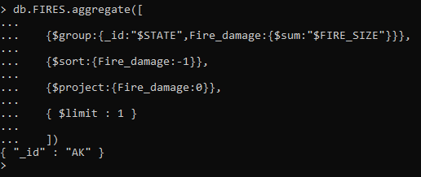

## Query 2

### One of the reporting agencies has suggested that children be banned from its forests unless there is one adult for every 3 children in a group visiting a forest. Name 3 forests where this would be the most appropriate.

### As the reporting agencies has suggested every 3 children should be accompanied by one adult, we group by source reporting unit in descending order and selecting first three forests will give us 3 documents.

### Translation: Report the source_reporting_unit_name where the source_reporting_unit_name contains forest and stat_cause_code is 8 by sorting them in descending order.

### Screen Shot of MongoDB Query/Code and Results:

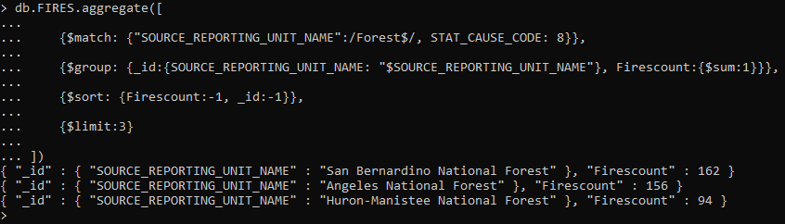

## Query 3

### One advocacy group says human actions and not Nature is to blame for most wildfires. Write a query that supports this statement.

### As the statement states human actions are to be blamed for most wildfires, we need the count the number of fires that are caused by human and nature. If the count of fires caused by human are more this proves the above statement is true. 2 documents are retrieved.

### Translation: Projecting the summary which contains human and nature. If the stat_cause_code is 1 then its nature else human based on which the count of each stat_cause_code is projected.

### Screen Shot of MongoDB Query/Code and Results:

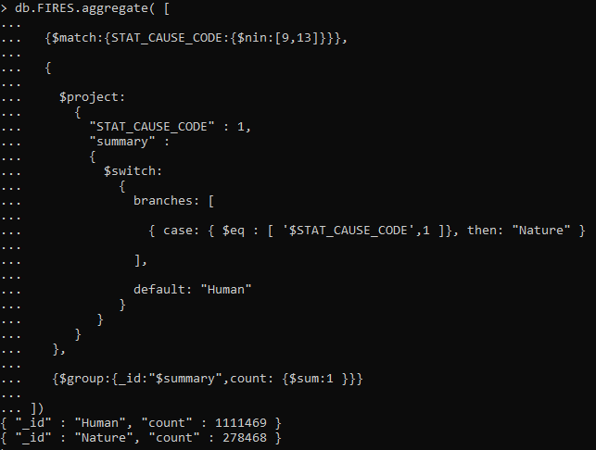

## Query 4

### How many wildfires were reported by more than one unit/agency?

### Retrieve the number of wildfires reported in more than one unit/agency. One document is retrieved.

### Translation: Projecting the fire_name and the source_reporting_unit where the no_of_units_reported is greater than 1.

### Screen Shot of MongoDB Query/Code and Results:

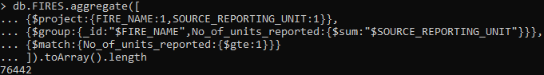

## Query 5

### What were the forests that had more than one fire that lasted more than two days?

### Retrieve the forests where the fires lasted for more than 2 days. 128 documents were retrieved.

### Translation: Projecting the source_unit_reporting_name where the difference between controlled date and discovery date is greater than 2 and source_unit_reporting_name contains “forest“ and firecount is greater than 1.

### Screen Shot of MongoDB Query/Code and Results:

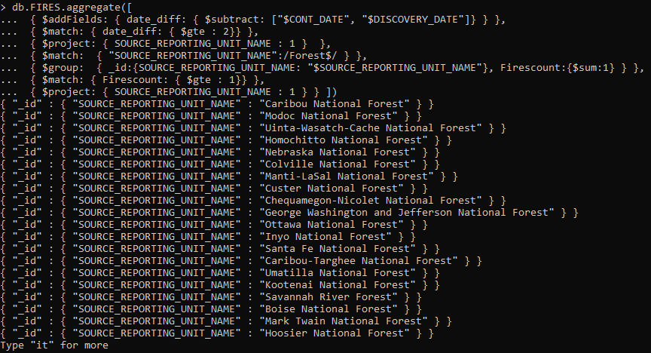

## Query 6

### Which forest had the most number of fires?

### Report the forest which has most number of fires. One document is retrieved

### Translation: Project nwcg_reporting_unit_name which contains “ forest“ by sorting in descending order.

### Screen Shot of MongoDB Query/Code and Results:

